CURRICULUM VITAE

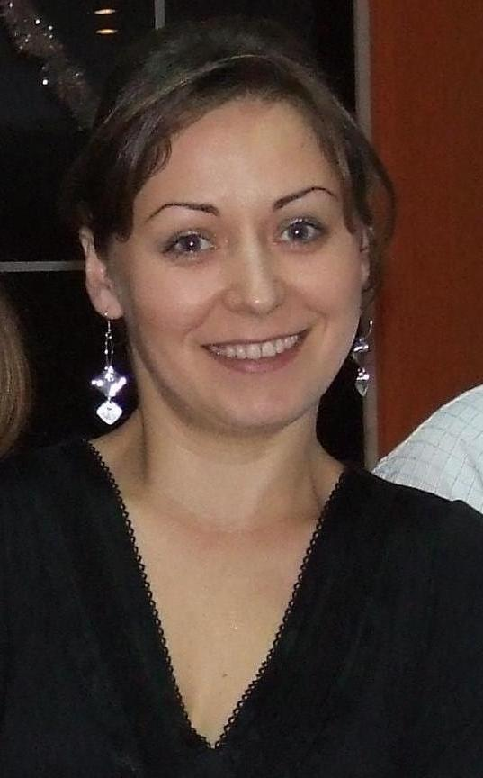
Name : Ioana Pop
Home address: Catalina 30 A, comuna Coltau
Jud. Maramures, Romania
Tel: 0040-743125141
E-mail: dorpop@yahoo.com
Date of birth: 16.07.1977
Nationality: Romanian (female)

Additional information:
- Married with one children aged 13.
- Full, clean driving licence.

Personal statement:

To be a good dental technician it’s very important to do everything well from the beginning.

Skills & Qualifications:

- Dexterity, attention to detail, pacience
- Communication, team work
- Good level of spoken and writing English and French.
- Work experience ( practice) in a dental laboratory:

- Pouring models
- Obtaining the working model (pin patern,cutting the mobile abutment,cutting the base,mounting in occlusion device)
- Obtaining a duplicate model
- Wax modeling for mobile prosthesesacrylic and skeletal prostheses, crowns, bridges, inlays
- Packaging
- Sanding,adjustments for the metal frame (crowns,bridges)
- Application of physionomic materials (acrylate,composite poliglass SIGNUM –HEREUS KULTZER)
- Mounting the acrylic teeth for the prostheses,polymerization
- Processing and final polishing

Job history:

2008-2011 Dental laboratory - Baia Mare ,Romania

I was working in a dental lab. to get experience
and to learn from a very talented technician, to
practice what I was learning in school.

2003-2007 Derry Court Co.Ltd . Dublin, Ireland

I went to Ireland and worked as a cleaning operator
and cleaning supervisor. I loved Ireland and the
time I’ve spend there so I wanted to get back, but
to do samething that I love.

2001-2003 Daytona com . Baia Mare , Romania

To work in a shop as a saleswoman was what I was
trained for in the High school ,that’s why I feel that this position
greatly enhanced my communication skills.

2000-2001 Diverse com. Baia Mare, Romania

I was a saleswoman in a food store, selling products
and doing orders, shop manager in my shift .

1996-2000 Primutil Srl. Baia Mare, Romania

My first job after finishing school ,it was a luxury shop; this was the
place where I learned to be a salewoman and because it was a large
shop I had to work in a team on each department so it was a training
that helped me a lot in the future.

Education:

2007-2010 Vasile Goldis - University - Faculty of dental medicine
Speciality DENTAL TECHNICIAN
I took the license exam with 92.6%.

1992-1996 Economical High school - Baia Mare
Speciality Merchant marchetologs
I took my high school exam with 93,6%

And courses: 2007 - People management course -Dublin
2007 - Real estate agent course
2006 - Infection control course -Dublin
1999 - Financial accounting course with computer applications

Referees: I am happy to supply these on request.

